Gas Agency Management System

ABSTRACT
The project entitled “Gas Agency” is done to make the manual process easier by making it a computerized system for billing and maintaining stock.
The Gas Agencies get the order request through phone calls or by personal from their customers and deliver the gas cylinders to their address based on their demand and previous delivery date. This process is made computerized and the customer’s name, address and stock details are stored in a database. Based on this the billing for a customer is made simple and easier, since a customer order for gas can be accepted only after completing a certain period from the previous delivery. This can be calculated and billed easily through this.
There are two types of delivery like domestic purpose use delivery and commercial purpose use delivery.

The bill rate and capacity differs for both. This can be easily maintained and charged accordingly. The stock of gas and all its details are processed swiftly.

CONTENTS
- INTRODUCTION
  - PROJECT OVERVIEW
  - PROJECT DESCRIPTION
- SYSTEM CONFIGURATION
  - HARDWARE SPECIFICATION
  - SOFTWARE SPECIFICATION
- SYSTEM ANALYSIS
  - PRELIMINARY INVESTIGATION
  - EXISTING SYSTEM
  - PROPOSED SYSTEM
  - FEASIBILITY ANALYSIS
  - ADVANTAGES OF PROPOSED SYSTEM
  - REQUIREMENT SPECIFICATION
- SYSTEM DESIGN
  - INTRODUCTION
  - DATA FLOW DIAGRAM
  - INPUT DESIGN
  - OUTPUT DESIGN
  - DATABASE DESIGN
- SYSTEM TESTING
  - TESTING METHODS
  - TEST PLAN ACTIVITIES
  - TESTING OBJECTIVE
  - SCREEN LAYOUTS
- SYSTEM IMPLEMENTATION
- CONCLUSION AND SCOPE FOR FUTURE ENHANCEMENT
- BIBLIOGRAPHY

INTRODUCTION

1.1 PROJECT OVERVIEW

A gas agency has number of customers whenever a customer need for booking of gas; they come and make a booking for refilling of gas.
Whenever a customer comes for booking his/her details are stored in booking register against booking number. When refilled cylinder is released, this is done in first come first serve basis .i.e. order of booking number.
When a customer joins, he/she is given a customer number and then his/her details are appended at the end of customer register. Similarly, for the incoming transfer of customer, after validating the customer details these are appended at the end of customer register.
The Gas Agencies get the order request through phone calls or by personal from their customers and deliver the gas cylinders to their address based on their demand and previous delivery date. This process is made computerized and the customer’s name, address and stock details are stored in a database. Based on this the billing for a customer is made simple and easier, since a customer order for gas can be accepted only after completing a certain period from the previous delivery. This can be calculated and billed easily through this.
There are two types of delivery like domestic purpose use delivery and commercial purpose use delivery. The bill rate and capacity differs for both. This can be easily maintained and charged accordingly. Stock available is also maintained in the stock register to determine the number of refilled, filled, empty, defective & price of refill.
1.2 PROJECT DESCRIPTION

The project entitled “Gas Agency” is done to make the manual process easier by making it a computerized system for billing and maintaining stock.
The Gas Agencies get the order request through phone calls or by personal from their customers and deliver the gas cylinders to their address based on their demand and previous delivery date. This process is made computerized and the customer’s name, address and stock details are stored in a database. Based on this the billing for a customer is made simple and easier, since a customer order for gas can be accepted only after completing a certain period from the previous delivery. This can be calculated and billed easily through this.
There are two types of delivery like domestic purpose use delivery and commercial purpose use delivery. The bill rate and capacity differs for both. This can be easily maintained and charged accordingly. The stock of gas and all its details are processed swiftly.
The following are involved in this project
- Customer Details
- Delivery Details
- Stock Details
- Billing Details
- Booking Details
- Price Details

SYSTEM CONFIGURATION

2.1 HARDWARE SPECIFICATION

Processor : Intel Pentium D

RAM : 256 MB

Cache Memory : 2MB L2 cache

CD Drive : Samsung 52X CD/R

Hard Disk Drive : 20GB

Monitor : 14”SVGA

2.2 SOFTWARE SPECIFICATION

Operating system : Windows 2000/Windows NT/XP/VISTA/7

Front-end : Visual Basic 6.0

Back-end : SQL Server 2000

SYSTEM ANALYSIS

3.1Preliminary Investigation

Preliminary investigation is a problem solving activity that requires intensive communication between the system users and system developers. It does various feasibility studies. In these studies, a rough figure of the system activities can be obtained, from which the decisions about the strategies to be followed for effective system study and analysis can be taken.
At the preliminary investigation an initial picture about the system working is got from the information got from this study, the data collection methods were identified. Right from the investigation about the system many existing drawbacks of the system could be identified, which helped a lot in the later stages of more rigorous study and analysis of the manual system.
The most critical phase of managing system projects is planning. To launch a system investigation, we need a master plan detailing the steps to be taken, the people to be questioned, and the outcome expected.

3.2Existing System
The existing system is a manual system. In the present Gas Agency system, all the activities are done manually. All data entry is performed by writing data into the book, paper documents. The bills are prepared manually, so there is a chance for occurring errors and the calculations are not so accurate. Various information’s such as customer details, product details, supplier details stock and customer requirements are handled manually. When there is need for retrieving details searching is unavoidable this is a difficult task searching the records manually .This is also too much time consuming when we want to retrieve details according to some specific conditions. There are many disadvantages in manual system. They are:

- Book keeping charge:
We have to keep the record in the large amount of books which may incur much cost. We have to spend lot of money to buy a new book when one book gets completed.

- Inaccuracies:
Since all the data entry is done manually in book of records, inaccuracies can occur. Cause of error is more in manual system.
- Expensive:
Large number of personal hours is required for each and every part of the manual system. We have to buy lot of books, paper for keeping the information. So the existing system is very expensive.
- Inefficiency:
Large volume of data and unformatted outputs lead to inefficient decision making. Inefficiency in the existing system is also caused by the lack of proper communication between the people of the organization.
- Time and effort
Large amount of time and efforts may require. For searching a particular data, we have to search all the paper documents, its corresponding book and find the data.
- All the searching are done manually:
In the existing system, all the work like entering the details of a Customer, Booking details, Stock Details etc.. are done manually. This is really time consuming.
3.3Proposed System
There are many disadvantages and drawbacks in manual system. We can solve this problem by using the computer based system. Our proposed system is computer based which can be very effective. Many advantages are there in this type of gas agency system. The main advantages of this proposed system are:
- Security:
The software used for this gas agency system include the password, so the security is provided. When anyone opens the software it has the provision for entering password. We have to enter the correct password; otherwise we cannot enter into the system. Password is saved in system registry for more security.

- User Friendly:
This package is very user friendly because it is easy to maintain and operate. All data entry operations are simple, administrator wants only enter data and all other operations are performed by the computer.

- Speed and Accuracy:
Computerization process increases the speed of all the operations. The manpower is reduced. Instead of doing all operation manually, computer will do it automatically. It also increases the accuracy of all the operations performed.

- Efficiency and flexibility:
The flexibility and the efficiency of all the operation in this gas agency system is increased because of the computerization. No errors are occurred compared to the manual system. Instead of searching lot of data, we can produce report in a few seconds.

- Formatted Output:
Each output of the proposed system is formatted in such a way so as to allow easy decision making. We can print the profile easily using data reports.

3.4 FEASIBILITY STUDY

Feasibility study is test of system proposal according to its workability, impact on organization, ability to meet the needs, effective use of resources. During the study, the problem definition is crystallized and aspects of the problem to be included in this system are determined. The result of the feasibility study is a formal proposal. If the proposal is accepted, we continue with the project.

FEASIBILTY CONSTRAINTS
- ECONOMIC FEASIBILITY
Economic analysis is most frequently used method for evaluating the effectiveness of a candidate system. More commonly known as cost/benefit analysis, the procedure is to determine the benefits and savings that are expected from a candidate system and compare them with costs.
The proposed system is economically feasible one. We do not want to keep lot of books for storing the data. By manipulating data using computer reduces cost. We do not want lot of employees; we simply want one to operate it, Administrator.
- TECHNICAL FEASIBILTY
Technical feasibility centers on the existing computer system and to what extend it can support the proposed system. It involves financial considerations to accommodate technical enhancements. If the budget is a serious constraint, then the project is judged not feasible.
Here we need only a computer working in low speed to accomplish the task.
- BEHAVIOUR FEASIBILTY
People inherently resist change and computers have been known to facilitate change. An estimate should be made of how strong a reaction the user staff is likely to have toward the development computerized system. The computer installations have something to do with turnover, retraining and changes to employee status.
In the proposed system, it behaves very feasibly. It is very easy to train the people in the proposed system. We simply want to tell the purpose of each button and about a little data to enter.
3.5 Advantages of Proposed System

- Users will receive better and quick service.
- Security is ensured by protecting the system with passwords.
- Normalized database tables eliminate data redundancy.
- Provision for minimizing errors in data entry.
- Efficient data storage.
- Real-time response and user-friendliness.
- Time saving.

3.6 Requirement Specifications

VISUAL BASIC 6.0

Microsoft visual basic is an event- driven programming language. It is a powerful programming language for the MS-Windows environment. It is used to create user-friendly interface. It provides a visual approach to the programming. Visual Basic provides a forceful graphic rapid application development. Visual Basic is based on the old BASIC language.
The “Visual” part refers to the method used to create the graphical user interface (GUI). Rather than writing numerous lines of code to describe the appearance and location of interface elements, you simply and rebuilt objects into place on a screen. If you’ve ever used a drawing program such as paint, you already have most of the skills necessary to create an effective user interface.
The “Basic” part refers to the BASIC (Beginners All-Purpose Symbolic Instruction Code) language, a language used by more programmers than any other language in the history of computing. Visual Basic has evolved from the original BASIC language and now contains several hundred statements, functions, and keywords, many of which relate directly to the windows GUI.
The most command components are used are forms, controls, classes, and procedures. Forms are windows upon which we build our user interface and controls are the building blocks of the user interface. Classes are templates from which we can create our own objects at runtime. These reusable class modules aid us in organizing our application into small components that can be building into a complete application.

SQL SERVER 2000

Microsoft SQL server 2000 is a full-featured relational database management system (RDBMS) that offers a variety of administrative tools to ease the burdens of database development, maintenance and administration. In this article, we’ll cover six of the more frequently used tools: Enterprise Manager, Query Analyzer, SQL Profiler, Service Manager and Data Transformation Services. Let’s take a brief look at each:
Enterprise Manager is the main administrative console for SQL Server installations. It provides you with a graphical “birds-eye” view of all of the SQL Server installations on your network. You can perform high - level administrative functions that affect one or more servers, schedule common maintenance tasks or create and modify the structure of individual databases.
Query-Analyzer offers a quick and dirty method for performing queries against any of your SQL Server databases. It’s a great way to quickly pull information out of a database in response to a user request, test queries before implementing them in other applications, create / modify stored procedures and execute administrative tasks.
SQL Profiler provides a window into the inner workings of your database. You can monitor many different event types and observe database performance in real time. SQL Profiler allows you to capture and replay system “traces” that log various activities. It’s a

great tool for optimizing databases with performance issues or troubleshooting particular problems.

Service Manager is used to control the MS SQL Server (the main SQL Server process), MSDTC (Microsoft Distributed Transaction Coordinator) and SQL Server Agent processes. An icon for this service normally resides in the system tray of machines running SQL Server. You can use Service Manager to start, stop, or pause any one of these services.
Data Transformation services (DTS) provide an extremely flexible method to import and export data between a Microsoft SQL Server installation and a large variety of other formats. The most commonly used DTS application is the “Import and Export Data “wizard found in the SQL Server program group.

SYSTEM DESIGN

4.1 INTRODUCTION

System design is a transaction from user-oriented documents to document oriented programmers or database personnel , it emphasis on translating performance specification into design specification and involves conceiving, planning and then carrying out the plan by generating the necessary reports and outputs. Design phase act as a bridge between the software requirement specification and implementation phase, which satisfies the requirements.
In the design phase the detailed design of the system selected in the study phase is accomplished. Major steps in design are
- Method of data Captures and data input.
- Modification to be done to convert the existing system to the proposed system
- Operations to be performed to produce output and maintain the file
- Design input and output forms
- Output to be produced
A modular approach has been adapted in the development of the proposed system. Each module is designed for a specific application and they are operated independently.

4.2 DATA FLOW DIAGRAM

A data flow diagram is the best and easiest tool to represent the flow of the data in the project. It is otherwise known as bubble chart. It has the purpose of clarifying system requirements and identifying major transformations that will become programs in the system design. It is the major starting point in the design phase that functionally decomposes the requirements specifications down to the lowest level of detail. A DFD consists of a series of bubbles joined by lines. The bubble represents data flow in the system. In the normal convention a DFD has four major symbols.

- A Square defines source or destination of data.

- An Arrow shows data flow.

3. A Circle represents a process that transforms incoming data into outgoing data flows

4. An Open rectangle shows a data store

DFD OF THE PROJECT

Level 0
Gas
Agency
Management
System

Admin
Admin

gas

Customer

Booking

Stock

Delivery

Change Password

Level 1

Admin
Admin

Level1.1

Add

Customer

Delete

Id
Admin
Customer

Update

Level 1.2

Add

Booking

Delete

Update

Booking
Admin

Level 1.3

Stock

Update
Admin

Stock

Level 1.4

Delivery

Deliver
Admin

Stock

4.3 INPUT DESIGN

The input data are collected and organized to make data entry easy, logical, and error free. Each area in the input form should be identified should be specified for the user what to write and where to write.
A screen is an actually a display station that has a buffer for storing data. The main objective of screen design is for simplicity, accurate and quick data capture or entry.
The objective in the input design is to ensure that the data which will be processed by the system is collected and inserted into the system efficiently according to the specified requirements , and with the minimum errors. The basic design consideration that would satisfy the user requirements were as follows.
Our guidelines are:
- Use the same format throughout the project.
- Allow ample space to avoid data over crowding because it cause eyestrain and may reduce the interest of the user.
- Use easy tolerant and consistent term such as “add”, “Delete” and “close”.

4.4 OUTPUT DESIGN

Report design is very important concept in the computerized system, without reliable output the user may feel the entire system is unnecessary and avoids using it. The proper output design is important in any system and facilitates effective decision making.

The basic output considerations were as follows

- Simple and legible methods were used for output using standard display controls
- All the output screens were informative and integrative in such a way the user can fulfil his requirements
- Quality reports were made available to the user

4.5 DATABASE DESIGN

It is a process of designing the database file, which is the key source of the information in the system. The objective of database is to design is to provide storage and it contributes to the overall efficiency of the system. The file should properly design and planned for collection, accumulation, editing and retrieving the required information.

The primary objective of a database design are fast response time to inquiries ,more information at low cost, control of redundancy ,clarity and ease of use, accuracy and integrity of the system ,fast recovery and availability of powerful end-user languages. The theme behind a database is to handle information as an integrated whole thus the main objective is to make information as access easy, quick, inexpensive and flexible for the users.

Table Design
Consumer Details

Field | Data Type | Description
con_no | varchar(6) | Consumer number  (Primary Key)
fname | varchar (10) | First name
lname | varchar(10) | Last Name
aline1 | varchar(20) | Address Line1
aline2 | varchar(20) | Address Line 2
pin | varchar(7) | Pin
phone | varchar(15) | Phone number
doc | varchar(15) | Date of Connection
lastbook | varchar(15) | Last Booking
ctype | varchar(10) | Cylinder Type

Stock Details
Field | Data Type | Description
commercial | int | Commercial Stock
domesitc | int | Domestic Stock

Booking Details
Field | Data Type | Description
book_id | int | Booking id
con_no | varchar(6) | Consumer number  (Foreign Key)
dob | varchar(15) | Date of booking
noc | int | Number of Cylinder
stat | varchar(10) | Status

Rate Details
Field | Data type | Description
drate | int | Demestic Rate
crate | int | Commersial Rate

Deliver Details
Field | Data Type | Description
del_id | int | Deliver id (Primary Key)
book_id | int | Booking id (Foreign Key)
dod | varchar(15) | Date of Delivery
con_no | varchar(6) | Consumer number  (Foreign Key)
noc | int | Number of Cylinder
price | varchar(10) | Price

Password Details
Field | Data Type | Description
Pass | Varchar(10) | Password

SYSTEM TESTING

5.1 Testing methods

In a software development project, errors can be injected at any stage during the development. Testing performs a very critical role for quality and for ensuring the reliability of software. During testing, the program to be tested is executed with set of test cases, and the output of the program for the test cases is evaluated to determine if the program is performing as it is expected to. Due to its approach, dynamic testing can only ascertain the presence of error in the program; the exact nature of the error is not usually decided by testing. Testing forms the first step in determining the errors in the program. Clearly the success of testing in revealing errors in programs depends critically on the test cases.

Testing is usually relied upon to detect the faults that occur during any phase of the software development cycle ,in addition to the faults that introduced during the coding phase itself. For this ,different levels of testing are used which perform different tasks and aim to test different aspects of the system. the basic levels of testing are unit testing ,integration testing ,system and acceptance testing. the different levels of testing attempt to detect different types of faults.

The main objective of testing is to uncover errors from the system. For the uncovering process we have to give proper input data to the system. So we should have more conscious to give input data. It is important to give correct inputs to efficient testing.

5.2Test Plan

UNIT TESTING

Unit testing verification efforts on the smallest unit of software design, module. This is known as “Module Testing”. The modules are tested separately. This testing is carried out during programming stage itself. In these testing steps, each module is found to be working satisfactorily as regard to the expected output from the module.

INTEGRATION TESTING

Integration testing is a systematic technique for constructing tests to uncover error associated within the interface. In the project, all the modules are combined and then the entire programme is tested as a whole. In the integration-testing step, all the error uncovered is corrected for the next testing steps.

VALIDATION TESTING

To uncover functional errors, that is, to check whether functional characteristics confirm to specification or not.

OUTPUT TESTING

The output generated or displayed by the system, under consideration is tested asking the users about the format required by them. Here, the output is considered into two ways: one is on the screen and other is the format.
The output format on the screen is found to be correct as the format design according to the user needs. For the hard copy also, the output comes out as specified by the user. Hence the output testing didn’t result in any correction in the system.
USER ACCEPTANCE TESTING

User acceptance of a system is the factor for the success of any system. The system under consideration is tested for user acceptance by constantly keeping in touch with the perspective system users at the time developing and making of testing automation tool.
The testing of the software began along with coding. Since the design was fully object-oriented, first the interface were developed and tested. Then unit testing was done for every module in the software for various inputs, such that each line of code is at least once executed.
After all modules were coded, the integration test was carried out. Some minor errors were found in the output at the earlier stage and each of them was corrected. In the implementation of user interface part no major errors were found. After the software was completely developed, the testing was done. The output of the system is correct and accurate during the time of demonstration. We proceed the testing process in this way
Each and every program units are tested which is known as unit testing
Then, we check the logic of the program, were the input of one would affect the output of the order, which is called as series testing
We test the inputs to ensure that they do infant process contain transactions according to specification. This testing is named as positive testing.
Execution a program with the intention of finding errors does system testing.
We run the system with live data by the actual user. This known as acceptance testing.
The security level of the system is tested which prevents unauthorized access to the system and records the user names that performed any change to the records. This kind of test is known as security testing.
5.3 TESTING OBJECTIVE
Testing is a process of executing a programme with intention of finding an error. A good test case is one that has a high probability of finding an as-get undiscovered error. A successful test is that in which no error are found. The objective is to design tests that systematically uncover different classes of error and do with a minimum amount of time and effort.

  - SCREEN LAYOUTS
- 0 Login
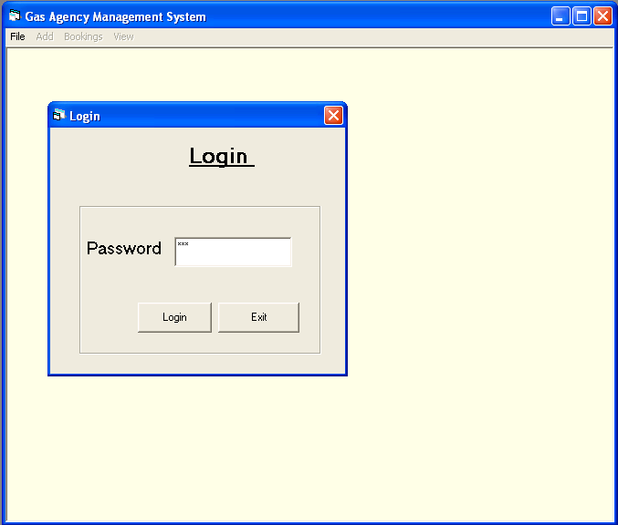
  - Main form
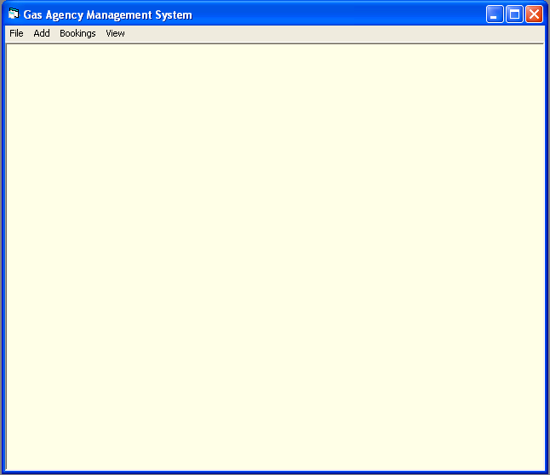
  - File Menu
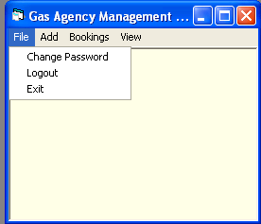
  - Add Menu
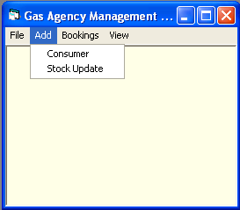
  - Bookings Menu
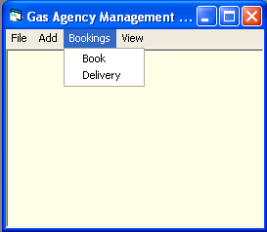

1.5 View Menu
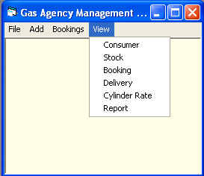

  - Change Password
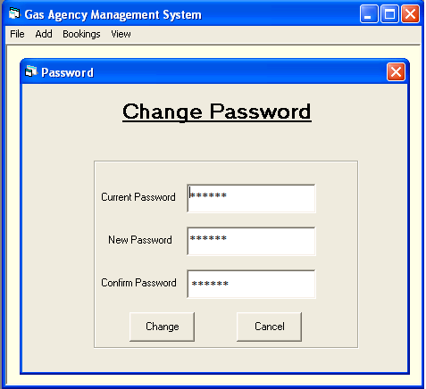

  - Consumer Entry
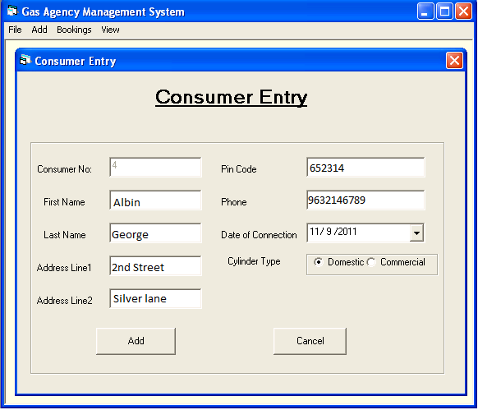
  - Stock Update
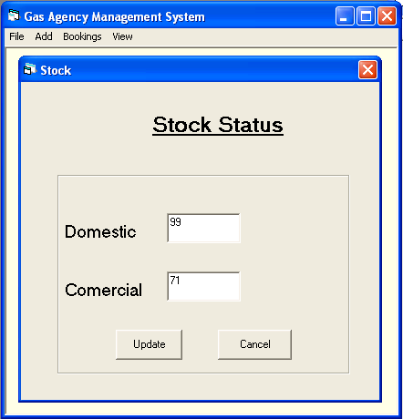
3.1.1 Booking
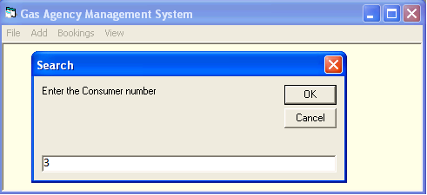
3.2.2 Booking
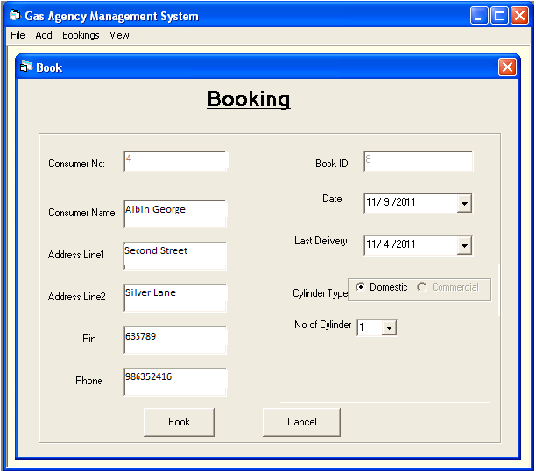

3.2.1 Delivery
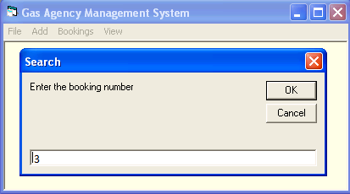
3.2.2 Delivery
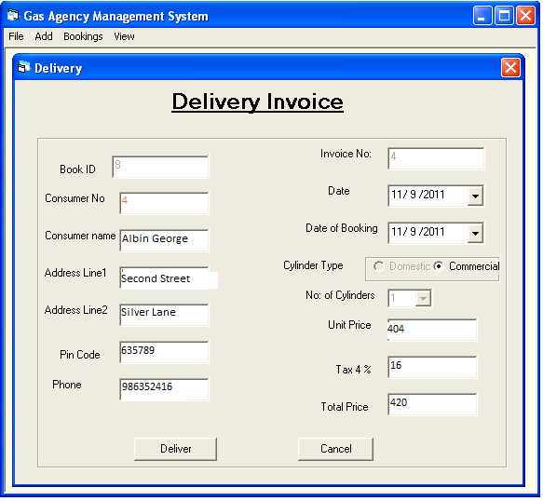

    - Invoice
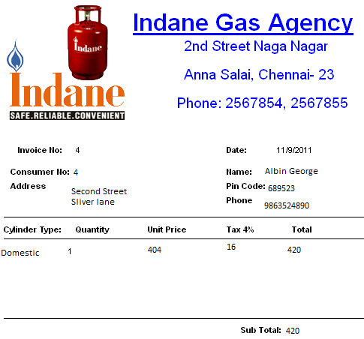

4.1.1 Consumer View
4.1.2 Consumer View
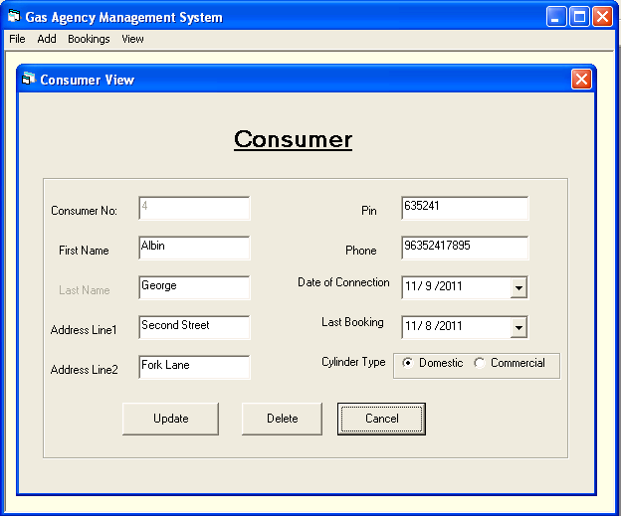

4.2.1 Booking View

4.2.2 Booking View
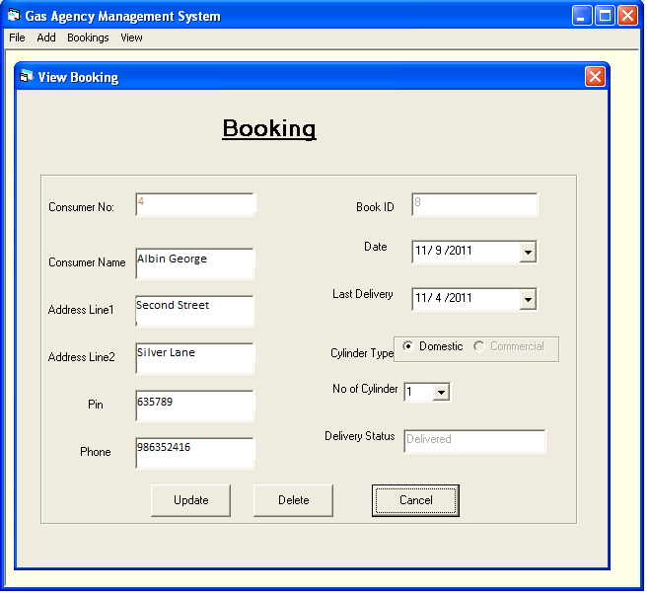

4.3.1 Delivery View
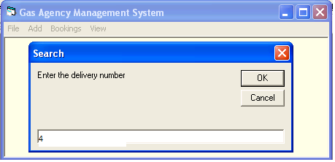
4.3.2 Delivery View
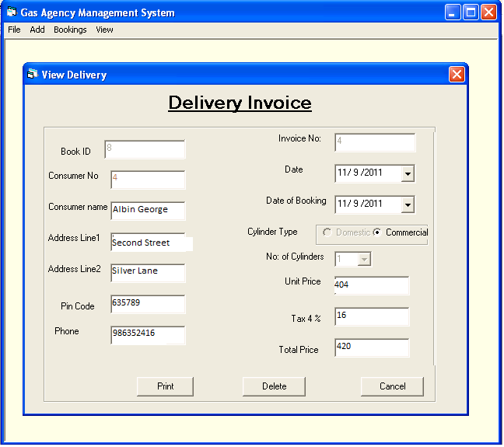

4.4 Cylinder rate
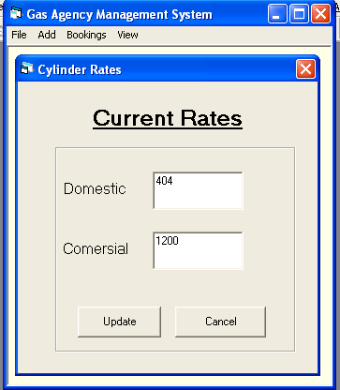
4.5 Report
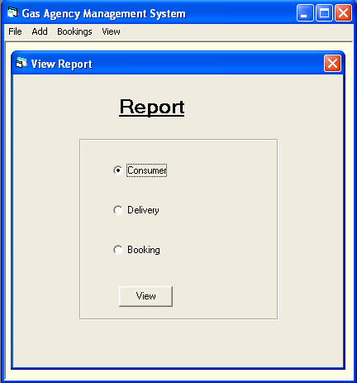
4.5.1 Consumer report
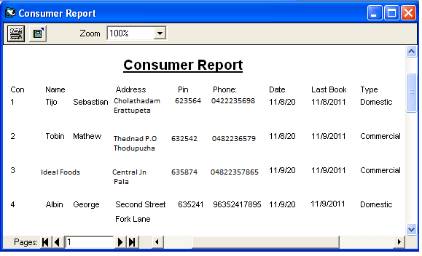
4.5.2 Booking Report
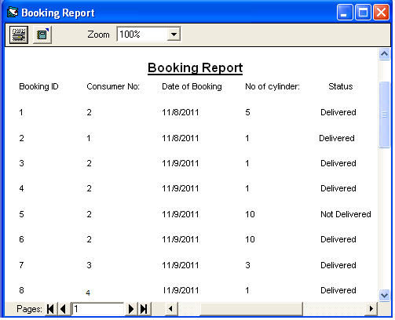

4.5.3 Delivery report
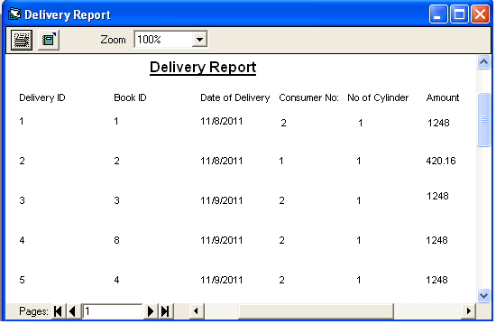

- SYSTEM IMPLEMENTATION
Implementation is the process of bringing a developed system into operational use and turning it over to the user. Implementation activities extend from planning through conversion from the old system to the new.

6.1 The Implementation Plan

At the beginning of the development phase a preliminary implementation plan is created to schedule and manage the many different activities that must be integrated into the plan. The implementation plan is updated throughout the development phase, culminating in a changeover plan for the operation phase. . The major elements of the implementation plan are test plan, training plan, an equipment installation plan, and a conversion plan.

- CONCLUSION AND SCOPE FOR FUTURE
GAMS (Gas Agency Management System) has been designed and developed according to the current requirements of a Gas Agency. The benefit expected from this is that it could reduce the burden of traditional method.
The major goal of the software is to create software that could automate all Gas Agency Related tasks. This software is very helpful to users who are searching for software for automating a Gas Agency.

7.1 ENHANCEMENT
This system is designed in such a way that addition of new modules can be done in a very simple and efficient manner. The future holds a lot to offer to the development and refinement of this project. As proper documentation exists the whole system flow is traceable. Some likely enhancements could be added in the future to enhance the capability of this system.
We may conclude that this software created will definitely find a good market in the Gas Agency to its maximum extend.

- BIBLIOGRAPHY

- Ramez Elmasri and Shamkant B. Navathe, Fundamentals of Database Systems Pearson Education, 5th edition
- Peter Norton’s Guide to Visual Basic 6 by Peter Norton and Michael Groh, Techmedia Publications
- Elements Of System Analysis Marvin Gore & John Stubbe, Galgotia Book Source.

